MAXIMISE THE RETURNS FROM YOUR MARKETING BUDGET
What effective card marketing programmes all have in common

It’s likely that many card marketers will look back on the industry a few years ago as The Golden Age.

Creditworthy customers scrambled to get cards, revenues burgeoned, charge-offs were low, and budgets were generous. What a change from today, where incomes are being slashed, costs are under huge pressure, and profitability is sagging.

Falling
revenues
Cost squeeze


But when the going gets tough, the toughest marketers get going. Today’s best-in-class card managers are focussing relentlessly on three key questions:

- How do I cut my acquisition costs?
- How do I find my most profitable customers – and keep them?
- How can I increase spend to compensate for falling fees and interchange?

To strengthen profit performance, it’s helpful to remind ourselves of the main streams of income and expenses. For a credit card, they look something like this:

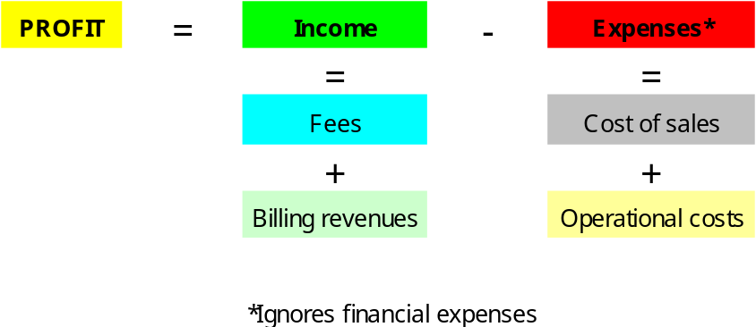

The check list which follows breaks out these streams – fees, billing revenues, cost of sales and operational costs – into their main elements, identifies the key drivers for each element, and proposes practical strategies to improve performance on every one of them:

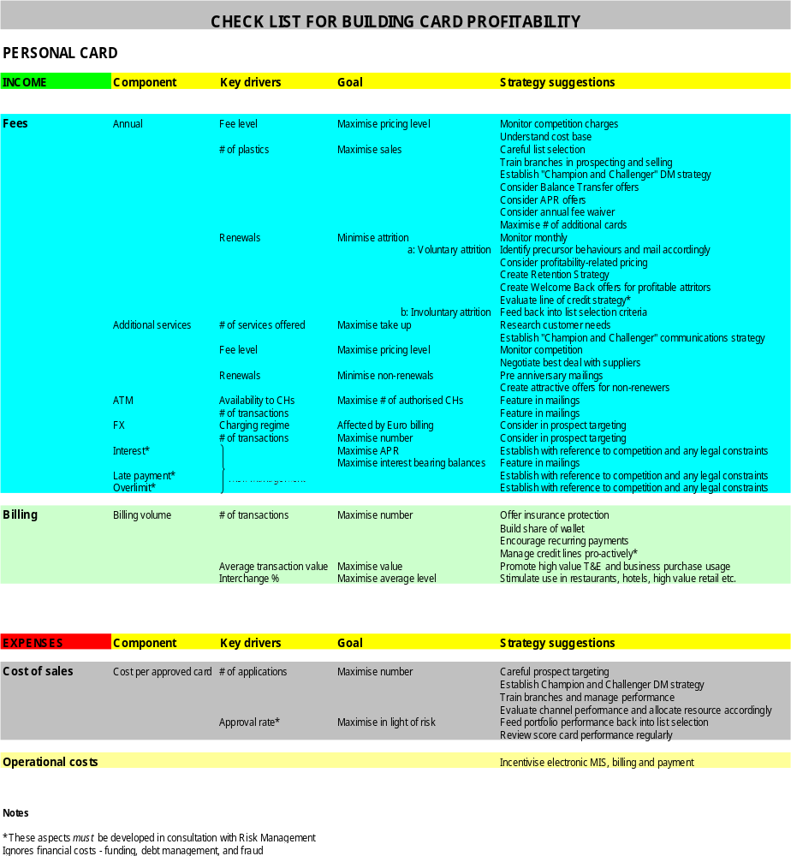

Source: Marketing Planning for Financial Services, Roy Stephenson, Gower, 2005

Let’s take a couple of examples of how this might work out in practice: leaders in anti-attrition strategies know that customers are much less likely to defect if their card gives them access to services which they see as valuable, or a nuisance to change. Valued services might include privileges at golf clubs, preferred access to airport lounges, or competitive rates on travel insurance. Services which would take time and effort to change might include recurring payments such as internet or magazine subscriptions. (It’s worth noting that, as well as increasing product “stickiness”, many of these features also make a useful contribution to account spend levels.)

Data-driven issuers have gone a step further than across-the-board offers: they’ve analysed past defector behaviour to predict accounts at risk in the future. For credit cards, one powerful example of precursor behaviour is paydown of balances owed without corresponding purchase debits. Profitable customers exhibiting these patterns are contacted with offers directly related to a resumption of activity (“Keep your account balance over £1000 for 12 months, and win this MP3 player”) or simply a Thank You on an account anniversary or client birthday. One Brazilian bank sends its most valuable customers a gift with a personally signed letter from the Division President on their birthdays. Other issuers organise special shopping nights at favoured stores, or tickets to special concerts and sporting events.

If all these efforts fail, win-back programmes target the most valuable defectors.

What all these efforts have in common is focus and discipline: focus to determine where the priorities lie, and discipline to implement strategies, measure performance, adjust, and execute again. When there’s a profit squeeze, there’s no substitute for clear thinking and controlled action.

© Roy Stephenson 2007

Barclaycard net down 14% in H1 of 2006 LONDON (Reuters) Thu Aug 3, 2006

